Is Thanos Right About Overpopulation In 'Avengers: Infinity War'? By: JV Chamary
The main villain of Avengers: Infinity War, Thanos, is a complex character who illustrates the depth of modern superhero movies. The story isn't a simple tale of good-versus-evil, but a battle of ideology. The bad guy explains why they do what they do, so although you'll disagree with their reasoning, you can at least understand the motivations behind their actions. Thanos is a god-like being who travels from world to world, killing the inhabitants. As Bruce Banner (Hulk) tells Tony Stark (Iron Man), "He invades planets, he takes what he wants, he wipes-out half the population." The villain doesn't perform these acts of mass murder just because he enjoys it, however -- he's collecting the cosmic 'infinity stones' for a gauntlet that would make him powerful enough to achieve his ultimate goal: a universe free from suffering.
The problem with people
Why might halving a population make the world a better place? Here on Earth, human overpopulation has been blamed for many of our biggest problems. For mankind, that includes pandemics, starvation and access to clean, fresh water. For the planet, that means pollution, and the collapse of biodiversity. In Avengers: Infinity War, Thanos explains that his home world of Titan faced similar problems, leading to a global catastrophe, which is why he feels compelled to 'save' the cosmos from the same fate -- by reducing its population. If we imagine overpopulation as a disease, rather than fighting symptoms such as climate change, why not treat the underlying cause: people? The concept of overpopulation is based on the assumption that our planet has a natural 'carrying capacity' -- a maximum amount of people it can support. On Earth, the human population has increased since the dawn of civilization around 10,000 BC. That rise was relatively slow before the Industrial Revolution, after which the growth rate increased dramatically. Today the world population is 7.6 billion and is projected to reach almost 10 billion in the year 2050.
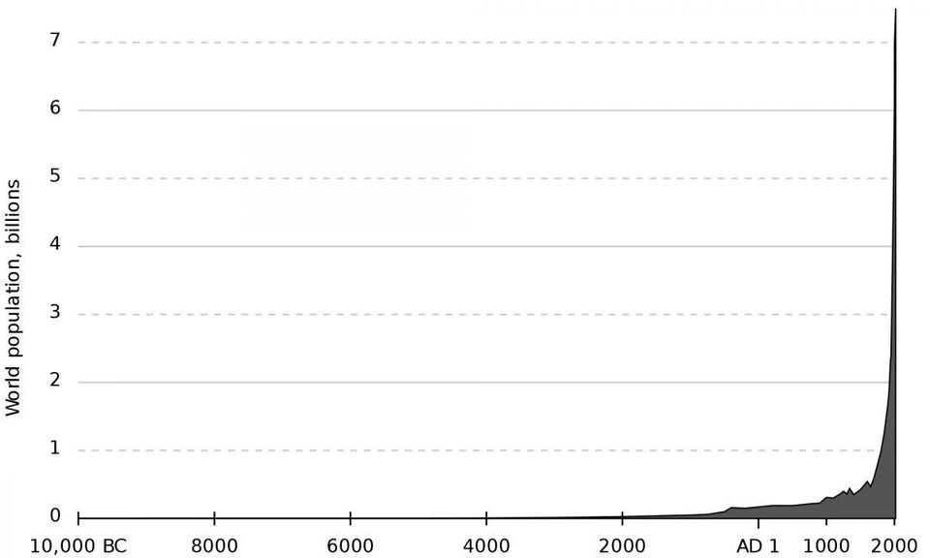
Carrying capacity, in turn, assumes that the world has finite resources. Within a given habitat at any point in time, things like food and habitat are limited, creating competition among individuals and groups, a major driving force behind evolution by natural selection. (Over a long period, the ecosystem recycles energy and biomass to replenish those resources.)
The two naturalists who independently developed the theory of natural selection, Charles Darwin and Alfred Russel Wallace, were both inspired by 'An Essay on the Principle of Population', published in 1798 by the economist Thomas Robert Malthus.
Malthus warned that if the global population continued to grow faster than the available food supply, it would lead to worldwide famine. More recently, in 1968 the biologist Paul Ehrlich wrote The Population Bomb, a book that highlighted overcrowding in cities and sparked a fear of overpopulation after claiming that hundreds of millions of people would starve to death.
Solutions to overpopulation
If the big problems for mankind and the environment are ultimately caused by too many people, how could we end overpopulation? As seen in Avengers: Infinity War, Thanos thinks the solution is simply to wipe-out half the population. This fictional scenario is obviously wrong from a moral perspective, which is why Earth's mightiest heroes try to stop him. But is Thanos actually right about the potential outcome, that reducing numbers would be better in the long run? In reality, population size is the net total produced from rates of birth and death (in a geographical area without barriers, such as a country, it's also influenced by factors like migration). Thanks to better sanitation, medicine and healthcare, the global rate of deaths hasn't decreased for hundreds of years, so it's unlikely that overpopulation would be slowed by higher mortality.
The other route to preventing population growth is lower fertility. Reducing births has led to some controversial programs, the most well-known being China's one-child policy, which prompted millions of forced abortions. Other approaches could help, such as better education, family planning and improving the status of women in certain countries. However, because over-breeding is more common in poor, developing nations, trying to fix their problems could be interpreted as racist.
But is the issue really too many people? While statistics like 10 billion people in 2050 imply a straightforward relationship, other figures show that it's a complicated issue. For example, The Population Bomb's prediction on world hunger hasn't come true: according to the United Nations, the proportion of undernourished people has dropped from 37% to 11%. Earth produces more than enough food to feed everyone, which suggests that global hunger is down to shortcomings in local policy and distribution. Thinkers such as environmental writer Fred Pearce believe that the real issue is not overpopulation but overconsumption, as people in developed nations -- in particular rich countries -- consume far more resources than they actually need. Current overpopulation might also be a temporary concern. Although population growth hasn't stopped, it has slowed significantly, and some projections predict the stats will plateau, or peak then decline, at about 11 billion around 2100. The overpopulation concept also assumes Earth has limited resources due to a carrying capacity, but that might be irrelevant because humans are able to use artificial means -- farming and other technologies -- to engineer ecosystems and sustain populations beyond natural limits.
Overpopulation is clearly a complicated problem, so it's ironic that a complex supervillain like Thanos has over-simplified the issue to 'too many people'. Thanos is a mass murderer who believes his actions are a necessary evil that are required to achieve a greater good: an end to suffering. In his own mind, he's not a villain, but a kind of hero. That sounds terrible if you see him as a person, but Thanos probably considers himself to be an instrument of destruction, a natural disaster or mass extinction event -- one that will help save the universe.

