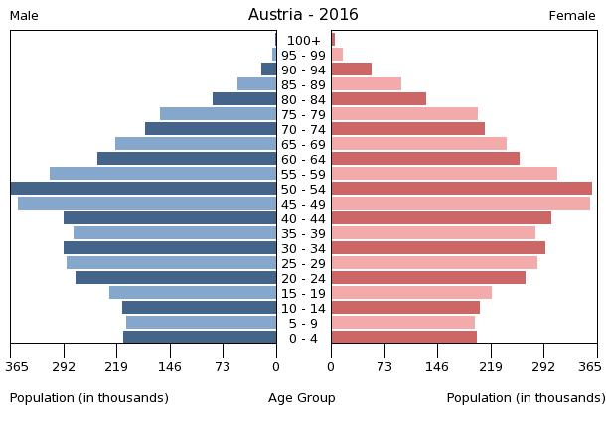

Remember TAGS:

1. Trends: Anything unusual or eye catching about the pyramid? Something that is very noticeable?
2. Ages: Where are the youth (under 19), adults (20-65), and elderly (over 65)?
3. Gender: Is there equality between genders or are there unusual amounts of one gender?
4. Shape: Is it a triangle, boxy, or an upside down triangle?

ssean

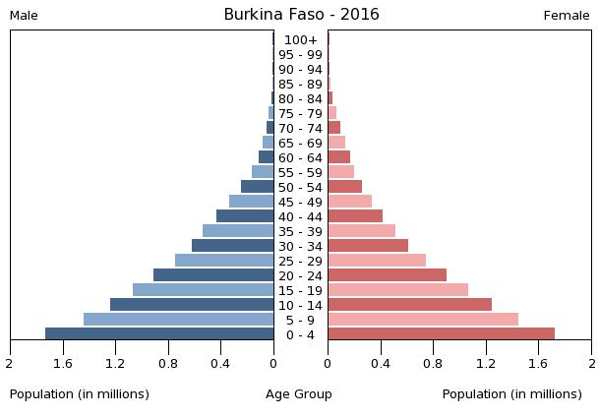

Remember TAGS:

1. Trends: Anything unusual or eye catching about the pyramid? Something that is very noticeable?
2. Ages: Where are the youth (under 19), adults (20-65), and elderly (over 65)?
3. Gender: Is there equality between genders or are there unusual amounts of one gender?
4. Shape: Is it a triangle, boxy, or an upside down triangle?

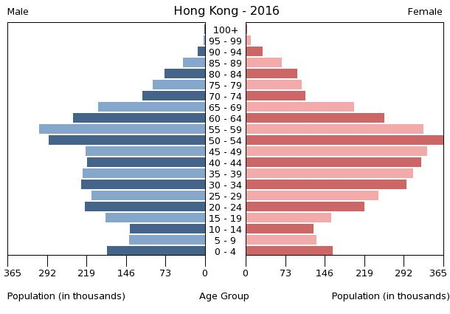

Remember TAGS:

1. Trends: Anything unusual or eye catching about the pyramid? Something that is very noticeable?
2. Ages: Where are the youth (under 19), adults (20-65), and elderly (over 65)?
3. Gender: Is there equality between genders or are there unusual amounts of one gender?
4. Shape: Is it a triangle, boxy, or an upside down triangle?

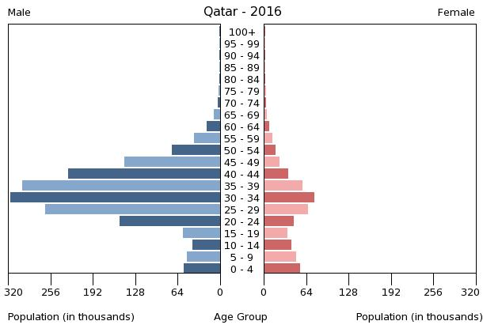

Remember TAGS:

1. Trends: Anything unusual or eye catching about the pyramid? Something that is very noticeable?
2. Ages: Where are the youth (under 19), adults (20-65), and elderly (over 65)?
3. Gender: Is there equality between genders or are there unusual amounts of one gender?
4. Shape: Is it a triangle, boxy, or an upside down triangle?

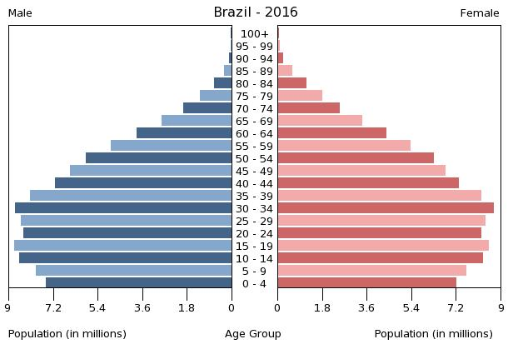

Remember TAGS:

1. Trends: Anything unusual or eye catching about the pyramid? Something that is very noticeable?
2. Ages: Where are the youth (under 19), adults (20-65), and elderly (over 65)?
3. Gender: Is there equality between genders or are there unusual amounts of one gender?
4. Shape: Is it a triangle, boxy, or an upside down triangle?

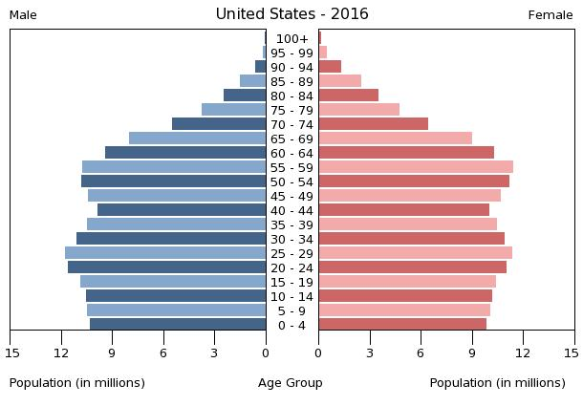

Remember TAGS:

1. Trends: Anything unusual or eye catching about the pyramid? Something that is very noticeable?
2. Ages: Where are the youth (under 19), adults (20-65), and elderly (over 65)?
3. Gender: Is there equality between genders or are there unusual amounts of one gender?
4. Shape: Is it a triangle, boxy, or an upside down triangle?

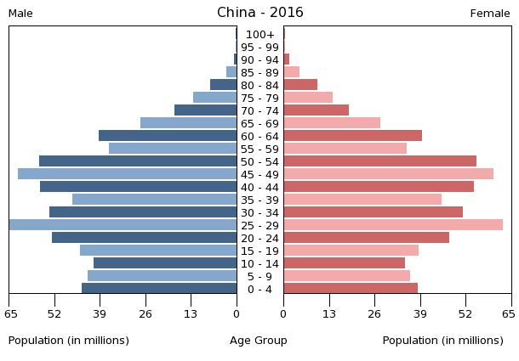

Remember TAGS:

1. Trends: Anything unusual or eye catching about the pyramid? Something that is very noticeable?
2. Ages: Where are the youth (under 19), adults (20-65), and elderly (over 65)?
3. Gender: Is there equality between genders or are there unusual amounts of one gender?
4. Shape: Is it a triangle, boxy, or an upside down triangle?

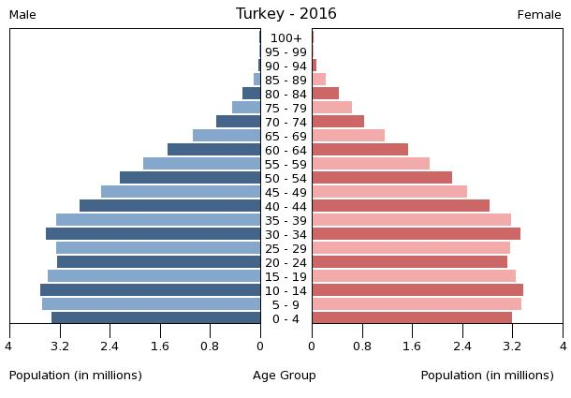

Remember TAGS:

1. Trends: Anything unusual or eye catching about the pyramid? Something that is very noticeable?
2. Ages: Where are the youth (under 19), adults (20-65), and elderly (over 65)?
3. Gender: Is there equality between genders or are there unusual amounts of one gender?
4. Shape: Is it a triangle, boxy, or an upside down triangle?