CASE STUDY 1: SCOTTISH INDEPENDENCE FROM U.K.
History
The Scots have a lengthy history when it comes to the United Kingdom. One of the original three regions that makes up Great Britain, Scotland merged together with England and Wales when England took over the region in 1707. Scotland had up until that point had its own independence and autonomy in the area until the creation of Great Britain. Despite being a different language, culture, and people, the Scots were forced to carry on with their English and Welsh neighbors under one united flag.
While Scotland has been recognized as its own county of the United Kingdom, most of the power has largely remained with England and, to a larger extend, the United Kingdom. Scotland was permitted to have its own legal system and constitution but most political matters were handled by the United Kingdom’s Parliament. It wasn’t until fairly recent in 1999 that Scotland was allowed to create its own Parliament to handle legal matters and political issues inside its borders.
In 2014, Scotland decided to hold a referendum, or vote, to see if they could begin the process of leaving the United Kingdom and to have their independence back.
Arguments for Independence
While culturally, the Scots are vastly different than the English and Welsh, most of the concerns of independence come from the political spectrum. People who push for an independent Scotland say that with independence and autonomy, they will have an equal standing with the other members of the United Kingdom.
Bigger concepts focus on how to run the government as with independence, Scotland will be able to create its own laws without needing U.K. approval. They can create their own policies for immigration and reform on their own terms. Furthermore, they can use resources in their own region to benefit themselves. There is an abundance of oil in the North Sea near Scotland, so they will be self-sufficient without needing any help from England.
Arguments against Independence
Numerous arguments against the independence vote for Scotland emerged during the initial vote. Some discussion points focused on the case of a unified, national identity; that Scotland’s global identity was tied to England and the U.K. Other debates came up about the need for Scots to carry passports to simply travel to any other region of the U.K. and Great Britain.
Impactful discussions arose throughout the ongoing referendum. One dealt with security. Already tied to the U.K., Scotland would need to produce its own army in order to defend itself from any outside attack. Being a member of a united region would prevent such issues. Another focused on the issue of economics and how Scotland makes decent money already with its ties to Great Britain than it ever would independently.
In the end, the arguments against would prevail as 55% of the voting population said ‘No’ to the idea of independence. With Great Britain agreeing to leave the European Union in 2016, Scotland has scheduled a new vote to take place in 2021 to bring up the question again ‘Should Scotland be an independent nation from Great Britain?’

CASE STUDY 1: SCOTTISH INDEPENDENCE FROM U.K.

- Briefly summarize the history of the Scots with Great Britain.

- Why would the Scots want their own country separate from the U.K.?

- What do you think is the most important argument for or against Scottish independence? Why?

- What potential/possible conflicts could come if Scotland had their own country? Give at least 2 examples.

- Should the Scots get their own country?

CASE STUDY 2: BASQUE COUNTRY IN SPAIN/FRANCE
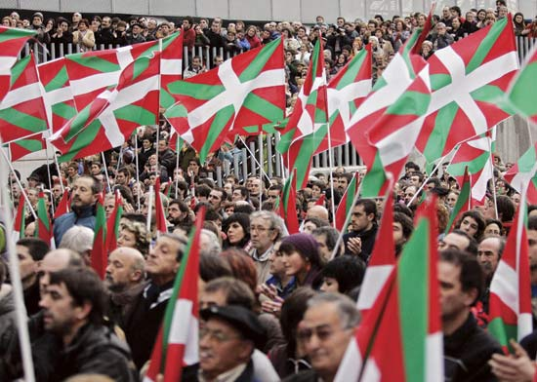
History
The Basque people are considered to be the oldest, continuous ethnic group in all of Europe. Dating back almost 3,000 years ago, these Europeans have remained nestled in the same area of north Spain and spreading across the Pyrenees Mountains into the southwest corner of France. Despite being pulled across two different states and nations, the Basque have preserved their language and way of life. Some customs, such as the famous running of the bulls, dates to Basque culture.
With over 2,000,000 citizens of the Basque territory, they have claimed that they should be independent from Spain as a whole. The large kingdom of Spain absorbed the smaller region 600 years ago but Basque people have done their best to keep some independence. With a different language, and overall different culture, Basque people pushed against Spanish governments controlling their lives. Violence has escalated in the past century but tensions between Spain and Basque Country have calmed down.
With Catalonia in south Spain pushing for independence the question has come up again with the Basque; should they too have their own independence?
Argument for Independence
With how isolated Basque people have been in the mountainous region of north Spain, they have developed their own culture and way of life. Vastly different from Spanish culture, Basque national pride lays claims that the people there should be independent as well. It does not help that Basque country had some level of autonomy until the 1800s when Spanish government took it away.
Even with some level of sovereignty, Basque country still needs to abide by all of Spain’s rules. Not helping the situation any is how much money Basque country makes for Spain. The region has ideal scenery for tourism and all money made goes right to Spain’s government, not the Basque’s. With its own level of independence, they can use the money for their own internal issues as opposed to funneling it straight to Madrid.
Argument against Independence
Considering how violent acts of terrorism have ceased only in the past ten years, some Basque believe it is too soon to all of a sudden demand independence. Most citizens are pleased to have some level of self-governance in the area. With a long history of suffering under the various kingdoms of Spain, the Basque have more freedoms than in previous centuries.
Others point that Spain has suffered from an economic recession, partly due to the lasting impacts of violence caused in Basque country. Some people feel that it’d be better to focus more on rebuilding the economy of Basque country as opposed to rebuilding a new nation.
Even with Catalonia pushing to seceded and leave Spain, people in Basque country seem disinterested in any push for independence. Out of the 2.2 million citizens of Basque country, roughly 23% agree to an independent country in some way or another.

CASE STUDY 2: BASQUE COUNTRY IN SPAIN/FRANCE
- Briefly summarize the history of the Basques with Spain.

- Why would the Basque want their own country separate from Spain?

- What do you think is the most important argument for or against Basque independence? Why?

- What potential/possible conflicts could come if the Basque had their own country? Give at least 2 examples.

- Should the Basque get their own country?

CASE STUDY 3: KURDISH SOVEREIGNTY IN MIDDLE EAST
History
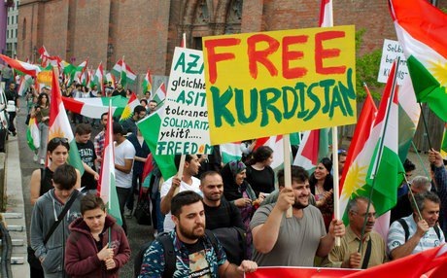
The Kurds are a Muslim ethnicity in the heart of the Middle East. With their own interpretation of Islam and gender roles, they are often set apart by neighboring countries who have their vastly different systems of life. Living in the area for centuries, Kurds enjoyed living in their own small communities. However, after the end of the First World War, the region and in turn, the Kurds, have changed drastically.
When World War I ended, several countries were created in order to split up territories. As such, Kurdish people were spread thinly across four countries: Iran, Iraq, Syria, and Turkey. They were promised their own country at some point after World War I but it never came to be. With no one place to call home, the Kurds have had to make due being in different countries at the same time. In recent history, some countries like Iraq granted Kurds their own autonomy in their portion of the country. Others like Turkey refuse, claiming that Kurds should not take any of their land.
With an ongoing war in Syria and Kurdish people fighting against ISIS, the matter of ‘Kurdistan’ has been on people’s minds now more than ever.
Arguments for Independence
One of the key arguments is how the Kurds were divided by European superpowers Britain and France. When they divided the land, they never considered any of the ethnicities in the region and drew lines haphazardly. Kurds were greatly affected by this decision and remain split with no united identity in the Middle East. There would be no harm in granting them a country as most countries they are a part of are unstable themselves. So long as they follow international laws, they should do as they wish.
Kurds also point out that they have been assisting local troops in the numerous battles against the ISIS terrorist group. As ISIS is strongest in both Syria and Iraq, causing chaos and instability in them, Kurds have taken up arms to help defend their home state. Dedicated to pushing back the extremist group out of their area, they should be rewarded with some country. Or at the very least, sovereignty.
Arguments against Independence
Many argue that now is not the right time for Kurds to push for independence or any form or autonomy. Considering that ISIS’ main goal is to have a country where they can have their own extreme interpretation of Islam, creating a Kurdish country will send mixed messages to other groups in the region.
There are those that claim that if Kurds were to create their own state out of the Middle East, it would lead to further destabilization. World governments claim that the region is historically one of the most unstable areas of the world with numerous fragile states. Creating a Kurdistan now will only cause these problems to intensify, leading to further conflict and worse destabilization than before.
In September 2017, the Kurds in Iraq voted in a referendum to achieve their own autonomy. An overwhelming amount voted yes to the issue as they declared a form of sovereignty. Most world governments disagree, saying that it will cause more harm than good.

CASE STUDY 3: KURDISH SOVEREIGNTY IN MIDDLE EAST
- Briefly summarize the history of the Kurds with the Middle East.

- Why would the Kurds want their own country separate from others in the Middle East?

- What do you think is the most important argument for or against Kurdish independence? Why?

- What potential/possible conflicts could come if the Kurds had their own country? Give at least 2 examples.

- Should the Kurds get their own country?

